# **SunToWater Project**

# **RADIUS Authentication Procedure**



# Captive Portal Creation

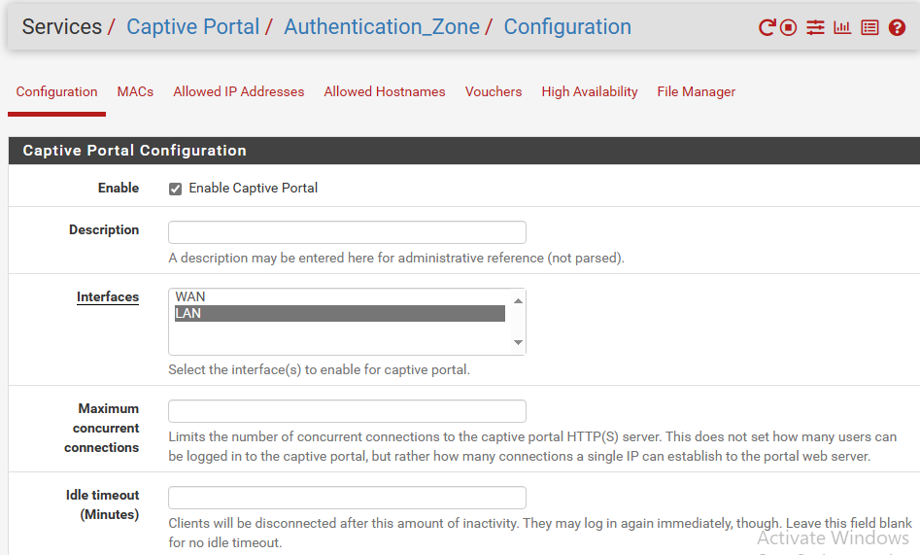

We start creating a captive portal by going to “Services / Captive Portal”.

Click the green button “+ Add”

Give it a name in this case we called it “Authentication_Zone”

From there we go to it’s configuration, click the checkbox “enable captive portal” to enable it and select in interfaces “LAN”

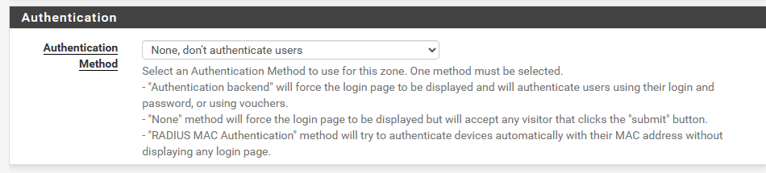

Next scroll down a bit and make sure the “None, don’t authenticate users” is selected on the Authentication method, we will come back to this in a later step.

Click the blue save button to save.

# FreeRadius Installation

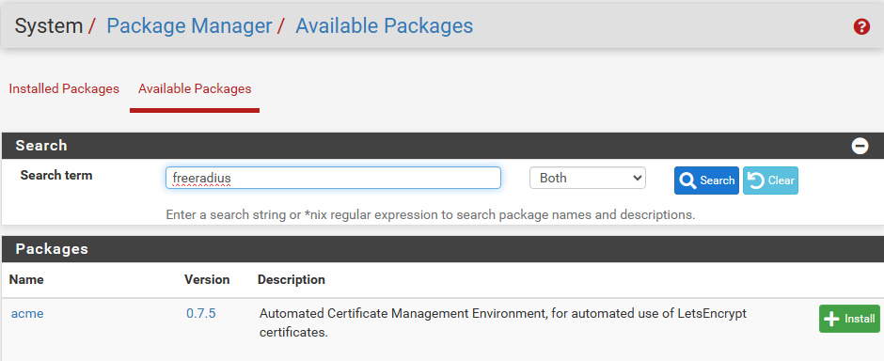

To install FreeRADIUS go to “System / Package Manager / Available Packages”

In the search term search freeradius and click the blue “search” button

The package will appear below (It’s already installed so it wont show up in the screenshot)

To install it, click the green “+ install” button

# 

# 

# 

# 

# 

# FreeRadius NAS/Clients Creation

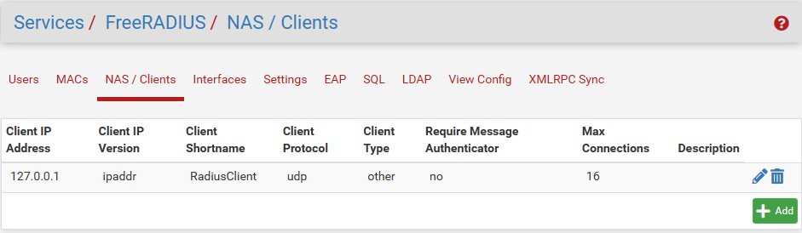

After installing FreeRADIUS, go to “Services / FreeRADIUS / NAS/Clients”, click the + Add button

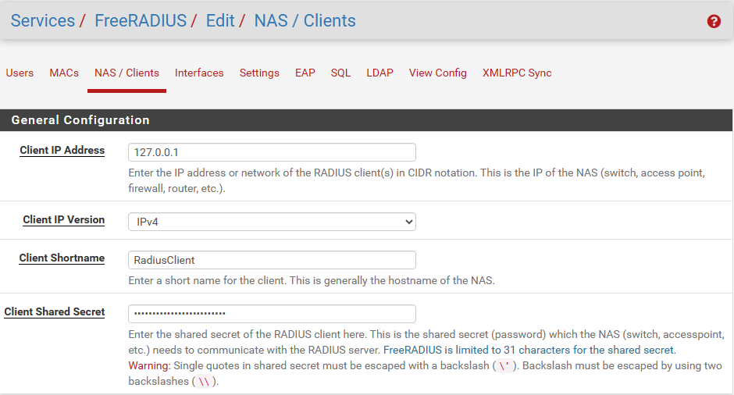

Here add the local host IP which is 127.0.0.1, give it a “shortname” and a “client shared secret” password

Make sure to write it down on a note for now because it will be used later.

# 

# 

# 

# 

# FreeRadius Interface Creation

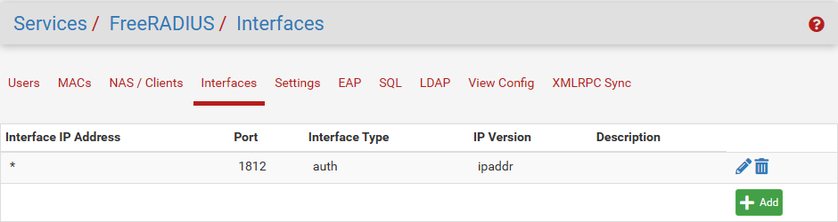

Next go to “Services / FreeRADIUS / Interfaces” and click the + Add green button

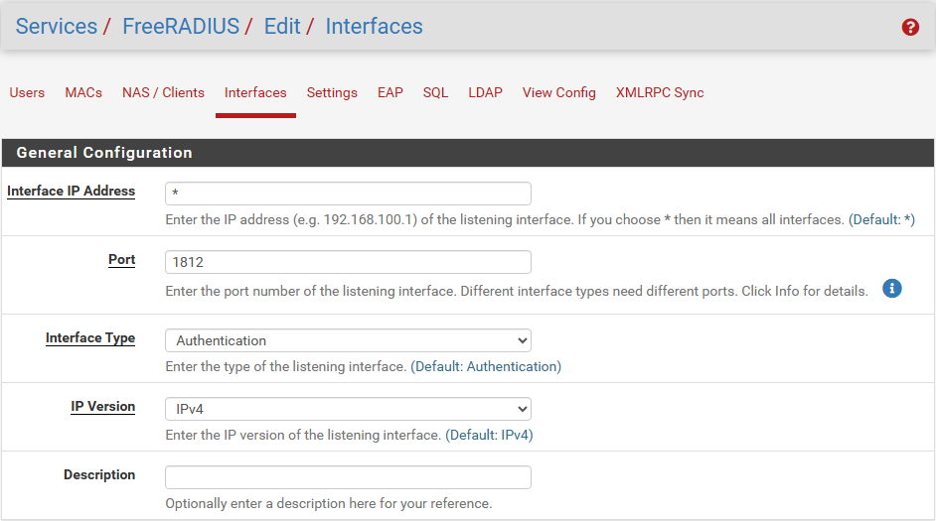

In here leave everything as default and save

# FreeRadius User Creation

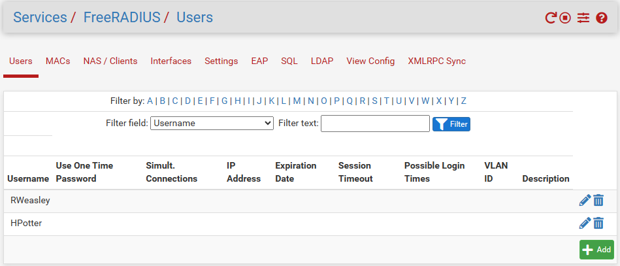

Next create a user by clicking the + Add green button

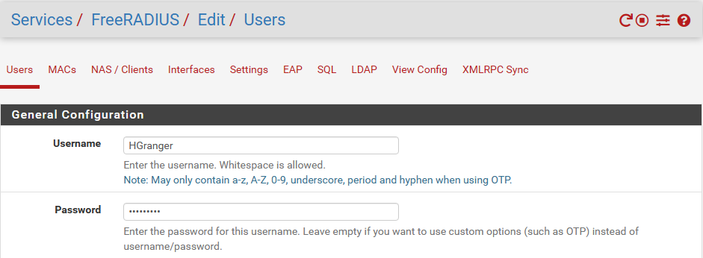

In here give a user name and a password, leave everything else on default and save

# 

# FreeRadius Authentication Server Creation

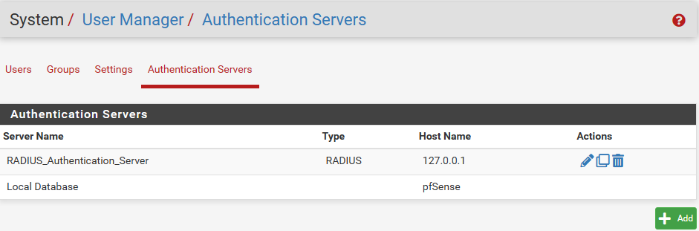

Next go to “System / User Manager / Authentication Servers” and click the + Add green button

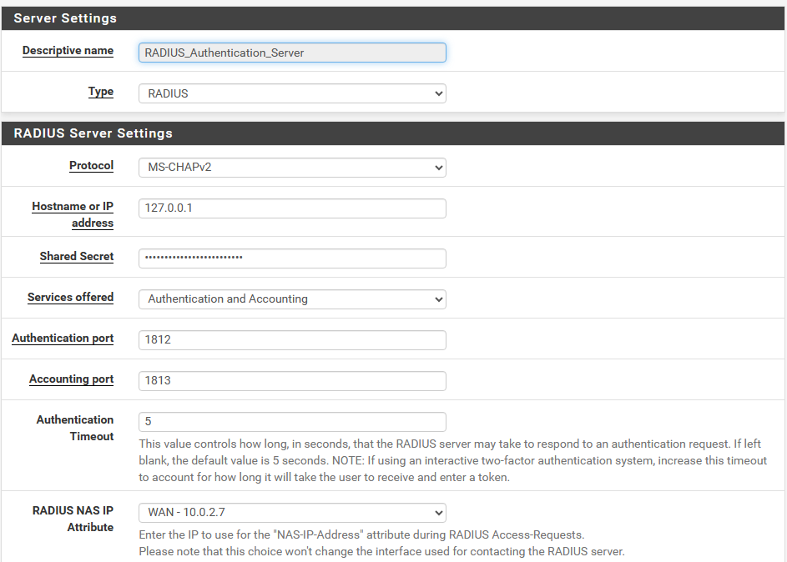

Give it a descriptive name, change the type to “RADIUS”, give it the local host ip address and the “shared secret” password created on a previous step

Leave everything else at default and save.

# Captive Portal Edit to use FreeRadius

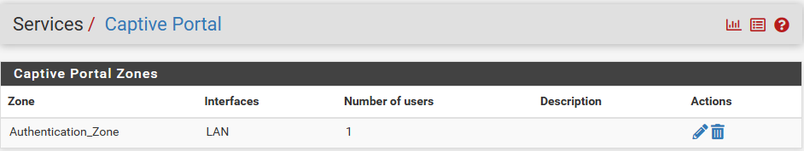

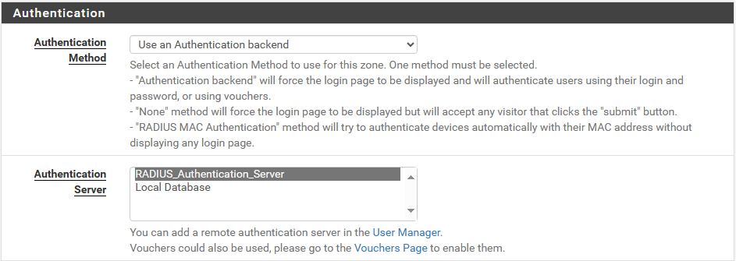

Go back to “Services / Captive Portal” click the pencil button to edit the portal zone.

In its configuration scroll down until Authentication is found, change the method to “Use an Authentication backend” and choose the previous authentication server created and save.

# Authentication Portal

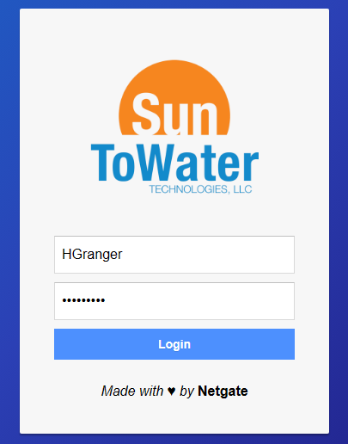

Now restart the pfSense machine and open a browser

It will show the Authentication portal and it will ask for credentials

Use the credentials from the user created in a previous step to login

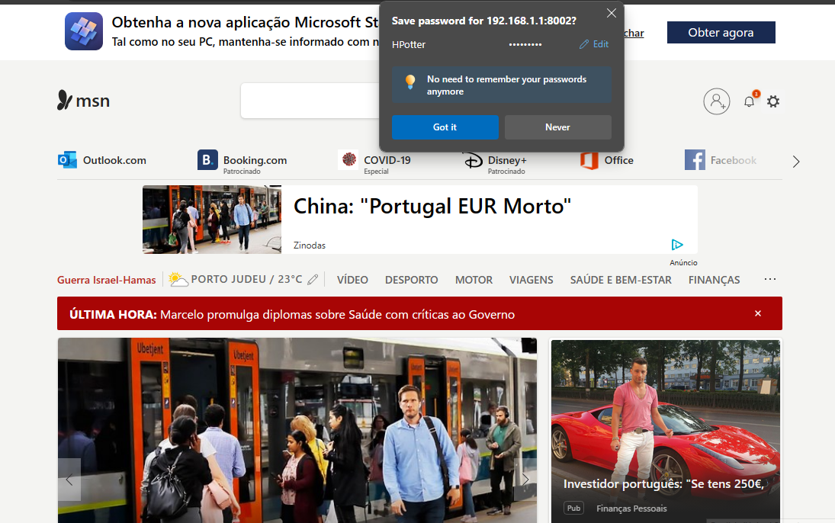

And If the credentials are correct it will redirect to a webpage!